Redirect to Submit manuscript, processing charges respectively – Link is not working

Hours list

Create Reviewer guideline page on live system 1 Hours

Create Reviewer guideline page in new theme 1 Hours

Setup Refund policy page and Call for paper page in new theme 1 Hours

Step By step how to publish page 2 Hours

Create indexing page and manage by cms 1 Hours

Create Reporting page and manage by cms 1 Hours

Create Testimonial management in backend 2 Hours

Editorial board view change 1 Hours

Editorial board set flag to show in front reviewer 1 Hours

Contact us and conf proposal emails 2 Hours

Setup Sms ,change sms templates and fetch data as per sms requirements 4 Hours

For resolve server storage issue spend 2 Hours

Article Number increase issue resolved 3 Hours

Map issue find and fix 2 Hours

Changeset 3 – GRD Website

Doubts:

Marquee text on menus for showing news feed (Not possible after menu. its disturb theme and color combination looks horrible)

Okay, let it go

Send me social page links, i will set in footer

Fb: <https://www.facebook.com/grdjournals>

Twitter : <https://twitter.com/grdjournals>

linkedIN : <https://www.linkedin.com/in/grd-journals-235849109>

Blogger: <http://grdjournals.blogspot.in>

Wordpress: <https://grdjournals.wordpress.com>

Instagram : <https://www.instagram.com/grdjournals/>

Pinterest : <https://www.pinterest.com/grdjournals>

Tumblr : <https://grdjournals.tumblr.com/>

Indexing Partner link

Google Scholar : <https://scholar.google.co.in/citations?user=GFDfgr0AAAAJ>

Academia : <http://independent.academia.edu/GrdJournals>

Slideshare: <https://www.slideshare.net/grdjournals>

Issuu : <https://issuu.com/grdjournals>

Scribd : <https://www.scribd.com/user/305339703/GRD-Journals>

Index Copernicus: <https://journals.indexcopernicus.com/search/journal/issue?issueId=all&journalId=46907>

Research Bib : <http://journalseeker.researchbib.com/view/issn/2455-5703>

Please check and confirm all the logo and link properly set

send me refund policy text, so i can create page and put it.

Remove that menu from author menu, put policy menu in footer only

Provide call for paper page content

Call For Paper – GRDJE March 2018

Global Research and Development Journal For Engineering (GRDJE), Invites authors worldwide for submitting their manuscripts/articles/papers for publication in ***Volume 3 Issue 4*** of ***March 2018*** issue of GRDJE.

The articles would be published online only and can be submitted here

CMS page editor Button not

Submit Manuscript Now

possible so I set The link

Backend this page manage through

CMS

The articles can be submitted and sent for review for free. The content of articles must be unique, original, previously unpublished and should involve no copyright infringements with authors’ responsibility.

All authors must ensure their manuscripts should follow the author guidelines by GRD Journals. Also manuscript should be rewritten using GRDJE paper format available on website.

Once submitted, Manuscripts would pass through peer reviewing process by GRD Journals. Author will be notified through email/phone regarding acceptance/rejection.

Subject Category:

All branches of engineering and mathematics falling into research areas of GRDJE.

**Benefits:**

Easy and fast publication process with tracking.

Free peer reviewing with review reports and content suggestions.

Indexing in major bibliographic databases like Google Scholar, Academia, Index Copernicus(IC), Issuu, Slideshare, Scribed, research bible etc.

Certificate hard copies, detailed review reports and plagiarism reports (chargeable)

**Timeline:**

**Paper Submission Date:** From 26th Feb to 25th March 2018

**Review Notification**: Avg. 3-5 Days

**Publication Notification:** Avg. 1-3 Days

**Journal Factors:**

**ISSN(Online):** 2455-5703

**Frequency:** 12 issues / year

**Impact Factor:** 1.306 (Link)

**Index Copernicus(IC) Value:** 65.67

**Publication Charges:**

**Indian Authors:** 1200 INR

**Foreign Authors:** 100 USD

Home Page

# CallForPaper:

Page title: Call For Paper- GRDJE - Submit Your Manuscript

Sitemap: Home>GRDJE>Callforpaper

Replace full Page title in CMS to sort “GRD Journal For Engineering Impact Factor” replace to “Impact Factor”

Problem with create site map “”



Content: As Above, will be managed using CMS

This will appear in GRDJE section with new Item called “Call For Paper”

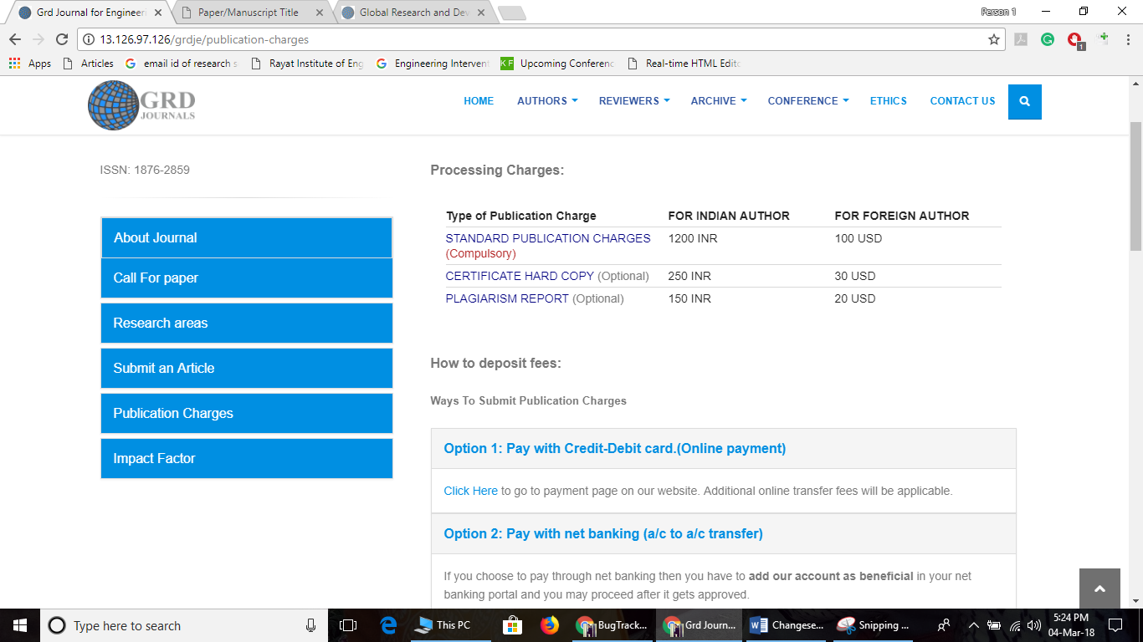

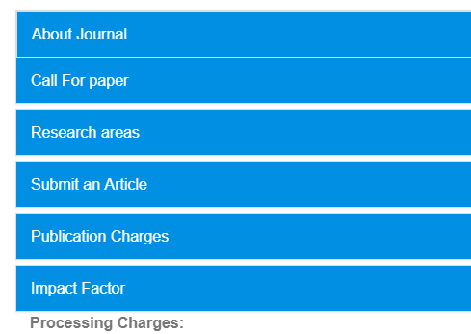

By default : About Journals menu should open.

# How to Publish Paper

* Title : GRD Journals – Publication Procedure
* Navigation : Home>Publication Procedure
* Title should be exactly like we have written

Step 1 : Step-by-step Manuscript Submission Process(For beginners)

This page will be bound with CMS and we will make the content

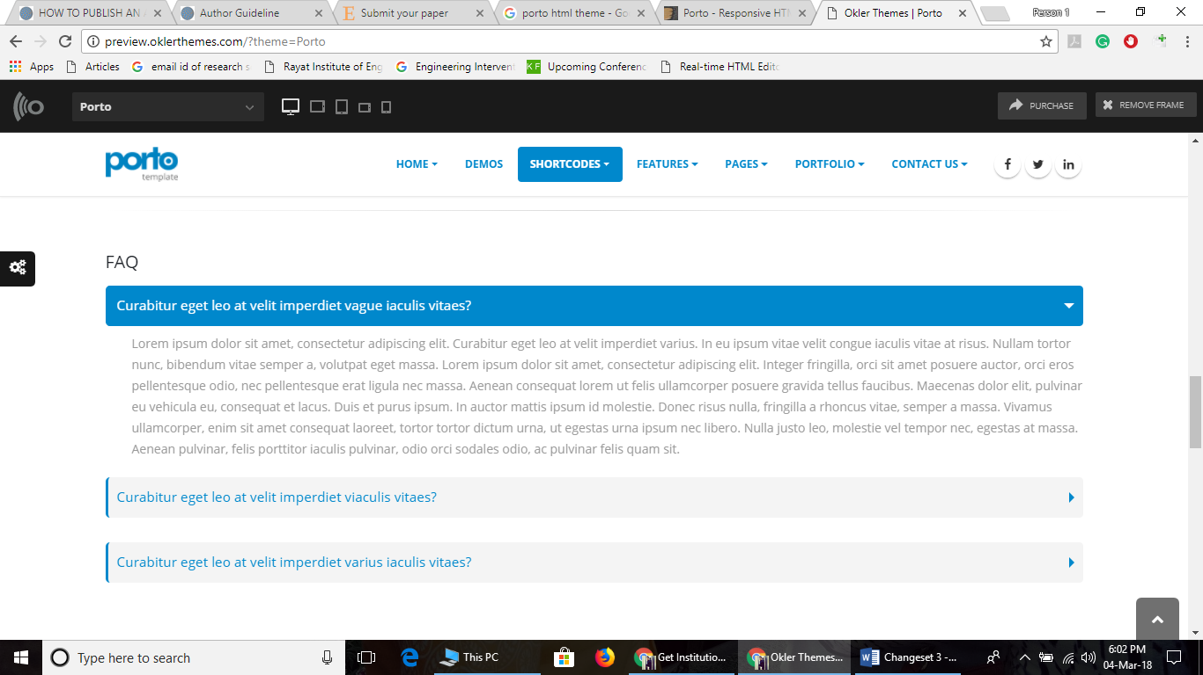

Title and content would look like above

Content is as below

1. Prepare Manuscript / Paper

Before you prepare your article for submission please go through our “Author Guidelines”. It is necessary that an author should create a content which must be unique, original, previously unpublished and should involve no copyright infringements with authors’ responsibility.

Every Journal has their own paper format and that will be available in journal details page. Make sure your paper is formatted into that format. Contact Journal authorities in case of any doubts.

Please make use of our archives available for free and open access. Here you might get help from the research fellows who have worked on subject and got their paper published.

It’s good practice to take references whenever necessary. Citation needs to be included for any work which is borrowed.

**Quick Links:**

Paper Format:

Author Guidelines:

Archives:

1. Submit Manuscript/Paper

After preparing manuscript, submit your manuscript in journal via submit manuscript page. Please keep your author name and email address handy.

The main author will be the person to communicate and will be communicated by journal whenever necessary. Please make sure the email address and phone numbers of main author are correctly written while submitting article. In case, if mistake happens, please email us at [info@grdjournals.com](mailto:info@grdjournals.com) immediately.

After submission you will receive an email containing manuscript id. Please keep it secured. Your manuscript id is necessary for any communication post submission of manuscript.

Quick Links:

Submit Manuscript

1. Tracking Manuscript:

After submission, you can track your manuscript using our track manuscript feature. This will let you know about current status of your manuscript.

Please keep your manuscript and registered email address handy when you are using this feature.

Quick Links:

Track Your Manuscript

1. Article Acceptance/Rejection:

The manuscript after submission will go through peer review process and committee will make the decision whether to accept or reject the manuscript. In both case, review report will be provided by journal to main author’s email address.

In case of rejection, author may rectify the mistakes mentioned in review report and resubmit the article again for review. There is no limit of attempts of submission.

In case of acceptance, author needs to check whether it’s acceptance with changes or without changes. If review report contains any suggestions, feedbacks from reviewer which is confirmed as mandatory change by editor then it must be modified and to be sent to our email address by mentioning modifications made.

Number of revisions in manuscript are 5. If article doesn’t qualify after that, it will be considered as rejected.

After clear acceptance author do not need to modify article.

1. Payment and copyright transfer

Once the article is accepted and no revision is required further, author can submit the payment. These two are mandatory and final steps for manuscript publication.

Payment mode and amount are available on website and also will be mentioned in email.

Once the payment is approved, author will be notified through email. Main author will be sent certificates of all the authors through email.

If certificates are not received within 2 working day of payment submission, please contact at [info@grdjournals.com](mailto:info@grdjournals.com)

Quicklinks:

Publication Charges

Download copyright form

Submit payment.

1. Publication

After payment approval and certificate assignment, article will be sent for publication. This takes 2 days after certificate assignment. Article, after publication will be available in journal archives in respective volume issue it was submitted in.

Articles are indexed in indexing libraries on timely basis depending upon journal’s decision.

For good amount of citation, authors can share it with their online communities such as blog, social media etc.

Step 2: Publication Flow Chart

Write “Publication Flowchart” instead of “publication chart”

# Submit Your Paper and Processing charge

Redirect to Submit manuscript, processing charges respectively – Link is not working

Not understand properly in my system all the link working proper

# Our Journals

|  |  |
| --- | --- |
| GRDJE | Global Research and Development Journal for Engineering  ISSN: 2455-5703  Impact Factor: 1.30  IC Value: 65.67 |

# 5.Features

* Open Access:

Freely accessible archives containing previously published research work.

Archives

* Publication:

Easy, double blinded and fast peer reviewing process by editorial board members from reputed institutions worldwide.

Publication Procedure Step By

* Indexing:

Indexing in well-known indexing databases across world.

**(Make Indexing Page With CMS)**

* Reporting:

Plagiarism reports, Free review reports for each review.

Indexing and reporting both page create and manage by cms

* Updates:

Article tracking and notification through phone/email.

track manuscript

# Numerics

3000+ Authors across world

500+ Reviewers Worldwide

30+ Issues Published

7+ Conferences hosted

# Testimonials

what i liked is they provide review report to authors so which are helpful to make changes. site is easy to use and responsive. But you have to wait or review to arrive. It can arrive between 1 to 5 days.

-Gorvadiya Jatin

Create Testimonial Management from backend

1. Quicklinks

what is the use of this

Menu:

1. **Author Menu :**

1. 1) ISSN No. Wrong ( Put 2455-5703)
2. Add ----->Submit Manuscript online link(afre author guidenlines)
3. 2) Manuscript Spelling wrong (it should be Manuscript not Menuscript)
4. 3) Remove paper template/format and copyright form and put it in download section
5. 4) Remove conference proposal
6. 6) remove refund Policy
7. 7) Remove FAQ

9. Remove ISSN from everywhere

Add Submit Manuscript online link

Please remember: Any links of GRDJE should always have breadcrumbs in pattern of HOME>GRDJE>PageName

Problem with name stored in database we need to rename page title mention above screen shots

Need to replace recaptcha with Google CaptchA NEW

For replace recaptcha we need to change many files and its not manage by terminal or manual edit

So this task done after ones theme changes upload on live

Place Check Your Paper content in center

-----

The editorial board will show the carousel of top 20 editors in our list

It will show name in big letters and department in small letters. By clicking on it more details will appear like this

 

It should be containing values from DB

1. Image, If not then default image
2. Name In Blue As Showed
3. Qualification & Branch
4. Specialization – Data from Specialization

Image for reviewer and design remain this all reviewer coming from backend and set show in front checked

This should be scrollable

------------------

Contact us & conference proposal

request should be send in mail.

[info@grdjournals.com](mailto:info@grdjournals.com)

-----------------

Massage servicea

check and inform us

Message service working last template remain because I don’t know which action to send this sms

-----------

Make “Reviewer Guidelines “ Page with CMS

Menu should be in reviewer menu

-----------

Rename “Impact Factor” to “Journal Statistics”

GDRJE submenu selection patterrn to show active menu

Remain all this above 5 things

# Processing Charges:

There will be a dropdown to select Journal and will lead to the page for processing charges when selected particular journal.

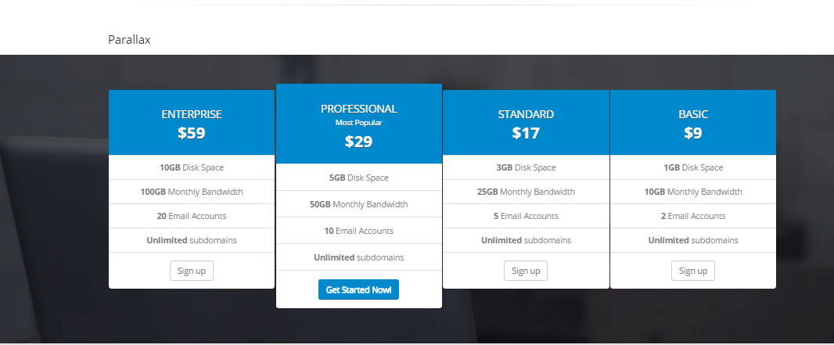

There will be HTMl part under this

**Standard**

1200 INR

Manuscript Publication

Review Report

E-Certificate

Indexing

**Professional**

1450 INR

Manuscript Publication

Review Report

E-Certificate

*Certificate Hard Copies(Incl. Delivery)*

Indexing

**Premium**

1600 INR

Manuscript Publication

Review Report

E-Certificate

*Certificate Hard Copies(Incl. Delivery)*

*Plagiarism Report(Incl. Delivery)*

Indexing

Please review charges page and give me same for **FOREIGN**author charge

Tell me unused text in this page so I can remove it

-----------------

Reviewer Guidelines Content

Any changes in processing charges we will discuss and change at a time I have done the page and design